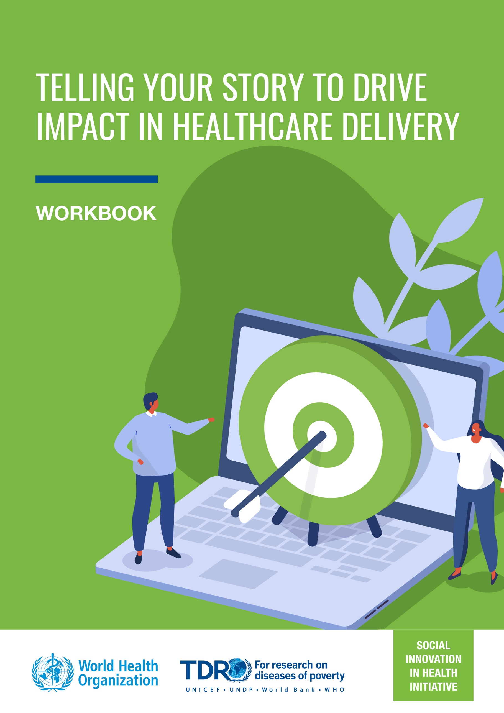

WORKBOOK
This is your workbook, where you will keep track of any notes or ideas throughout the course. You will also complete six learning exercises at the end of Modules 2 through 7.

These exercises will be based on an additional case study: a campaign to support the rollout of SIHI's monitoring and evaluation framework. The case study includes:

- Interactive Website
- Motion Graphic
- PDF Document
- Social Media Rollout:
  - Twitter post 1
  - Twitter post 2
  - Twitter post 3
  - Twitter post 4
  - Twitter post 5
- Full Social Media Campaign Report

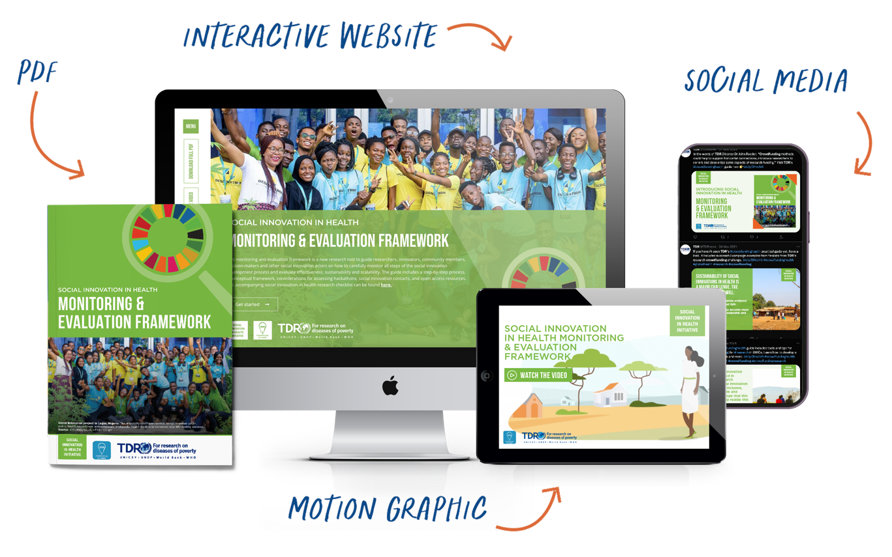

Together, these exercises will comprise your end-of-course assignment. This assignment is not graded; however, you will share your learnings and receive feedback on your thinking during the instructor-led session at the end of the course.

Module 1: Traditional communications vs storytelling

Thinking prompts | Notes
What is your current understanding of communications and storytelling?
Do you have any goals for this course or communications pain points you hope to address?

Module 2: The science of storytelling

Thinking prompts | Notes
Are you surprised by the science behind storytelling? How do your expectations compare to what you know now?
What value do you see in the four functions of storytelling, within the context of public health and social innovation?

Module 2 exercise:
You've observed how the four functions of storytelling are present in the Crowdfunding Guide campaign example. Now, look to the workbook example—the SIHI Monitoring and Evaluation Framework campaign—and outline how these four basic functions appear.

Function | Example
Demonstrate cause-and-effect relationships
Depict patterns and essential information
Build empathy
Capture attention

Module 3: Strategy

Thinking prompts | Notes
How has this module on storytelling strategy changed how you think about communications?

Module 3 exercise:
You saw how the Because Stories team used these three strategy questions the to gain insights into their target audience and to plan out their narrative structure for the Crowdfunding Guide campaign example. Now, look to the workbook example—the SIHI Monitoring and Evaluation Framework campaign— and attempt to answer the three strategy questions yourself.

Question | Answer
What’s your shared goal for collaboration?
Who can help you achieve that goal?
What do we want our audience to know, feel and do?

Module 4: Hero narrative theory

Thinking prompts | Notes
Has hero narrative theory changed how you think about storytelling?
Think back to the pain points you listed in module 1. Do you think this will help you address any of those?

Module 4 exercise:
With your new understanding of storytelling architecture and hero narrative theory, you can now appreciate how each of these characters contributes to creating impactful stories. Refer to the example in the workbook—the SIHI Monitoring and Evaluation Framework otion graphic—and identify the hero, guide, and villain.

Question | Answer
Hero
Guide
Villain

Module 5: Content creation

Thinking prompts | Notes
Has this module sparked any content ideas for a project that you’re working on?

Module 5 exercise:
In our case study for the SIHI Monitoring and Evaluation Framework campaign, we created the following:

- Interactive Website
- Motion Graphic
- PDF Document
- Social Media Rollout:
  - Twitter post 1
  - Twitter post 2
  - Twitter post 3
  - Twitter post 4
  - Twitter post 5
- Full Social Media Campaign Report

If you were running the campaign, and had the budget to expand your offering, what would you do differently, and why? What content pieces would you add to increase the storytelling value of the campaign?

Answer

Module 6: Engagement

Thinking prompts | Notes
Has this module changed the way you think about social media as a communications tool? Is there any way you plan to change the ways you currently use these platforms?
Can you think of ways you’ll use these insights to amp up engagement in other, more traditional channels, such as conference presentations?

Module 6 exercise:
Now that you understand how engagement not only sets the stage for but also equips you to monitor increased interaction with your audience, you can apply this knowledge to the SIHI Monitoring & Evaluation Framework campaign. Refer to the social media rollout and identify examples of the engagement techniques listed below.

- Social Media Rollout:
  - Twitter post 1
  - Twitter post 2
  - Twitter post 3
  - Twitter post 4
  - Twitter post 5
- Full Social Media Campaign Report

Question | Answer
Identify examples of broad, and niche hashtags that were used in the campaign. Suggest two to three related hashtags that could have worked.
Evaluate one of the CTAs used in the campaign. What specific action do you think the team was looking to drive here? Suggest an alternative CTA that would prompt the same outcome.
Select one of the social posts. Brainstorm two to three question prompts that you think could have been used in this prompt to drive comments.

Module 7: Evaluation

Thinking prompts | Notes
M&E is the backbone of effective research. Based on your expertise in this area, do you have any ideas for additional ways to monitor and evaluate communications campaigns more effectively?

Module 7 exercise:
Take a look at the metrics that came out of the M&E social media campaign. How do you think these results compare? What goals would you set for a follow-up campaign for the same target audience?

Answer

